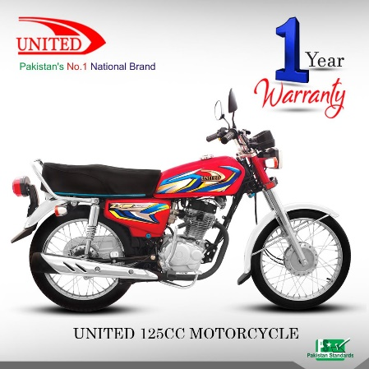

United 125cc Motorcycle (Lahore, Multan, Gujranwala, Sheikhupura, Sialkot and Faisalabad)

Product details of United 125cc Motorcycle (Lahore, Multan, Gujranwala, Sheikhupura, Sialkot and Faisalabad)

* ENGINE 4-STROKE SINGLE CYLINDER AIR COOLED
* BORE & STROKE 56.5x49.5
* CLUTCH
* WET TYPE MULTI PLATE
* STARTING KICK START
* DIMENSION(LxWxH) L=1900MM,W=710MM, H=1040MM
* PETROL CAPACITY 9 Litre
* TYRE AT BACK 3.00-17
* DISPLACEMENT 125cc
* COMPRESSION RATIO 9:0:1
* TRANSMISSION 4 SPEED
* FRAME BACK BONE
* GROUND CLEARANCE 140MM
* TYRE AT FRONT 2.50-18
* DRY WEIGHT 94.5 KG